Design and Implementation of an Intelligent Lab to support Green IT

Mohammed Ahmed Youssef ¹, Samer Jamal Al-hebeshi ², Mohammed Amine Uldeen ³,Nawaf Al-Harbi ⁴,
M.Rizwan Jamal Qureshi ⁵, Fazal Qudus Khan ⁶

King Abdul Aziz University, silentevill@hotmail.com ¹, samergot@hotmail.com ², meedooo99@windowslive.com ³,
nawafiy.it@hotmail.com ⁴, anriz@hotmail.com ⁵ , fazalqudus@hotmail.com ⁶

ABSTRACT

We are proposing to solve an energy problem by saving the consumption of power as well as providing comfort environment to students and faculty. In the IT department at the Faculty of Computing and Information Technology (FCIT), Ten labs are critical place for consuming power, at the same time students cannot handle temperature of 16 degree coming from Air Conditioner (AC) while the outside is 22 degree which often happen in the Kingdom of Saudi (KSA). As a spiral project, we started from the labs. point to be noted here that KSA using oil as a major resource on priority to produce electricity, it will not last for ever. The world has shifted thinking now, to use ways to safer the environment and less population .

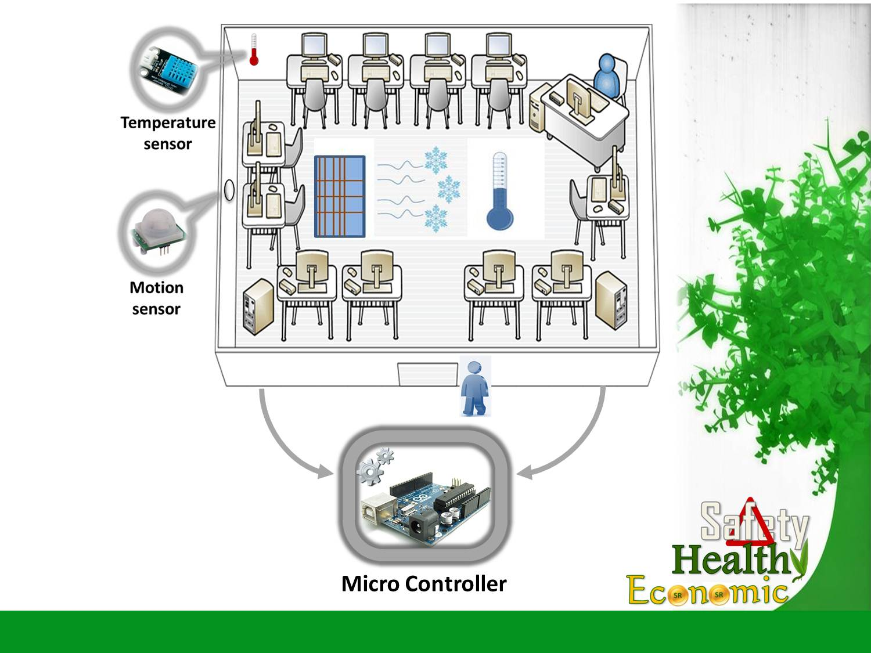
We are going to save AC power consumption by using
Ardunio Micro Controller as the control panel to all
Hardware, which has Four sensors.
There are three temperature sensors responsible
for measuring the temperature for labs, offices,
faculty Building and outside the building.
Beginning from the labs which have two sensors
One will be stuck on the roof and the other one on
the floor. We/ the Ardunio Microcontroller
will take the average of the two,
this average will be compared with the sensor that are
located outside. Depending on the final result it decide
either to balance the labs temperature by lowering or
increasing the temperature, or turn off the AC
to use fans.
Heat comes in case there is Someone inside the lab i.e. the
students and Personal Computer (PC) this will lead us to
the fourth sensor the Motion Sensor the job of which is
to detect any movement inside labs.
This can go two way, In the First case if there Is any
detection and the sensor, sensed Something then the work
flow will continue to temperature sensors.

In the second case, if the sensor doesn’t detect anything, which means no human being inside then there will be timer for 15 minutes (because PC sleep mode start after 15 mint if someone is using it, so that means that no heat emitted) once it finishes Sensing, the AC will turn off the compressor and only fans will be turned on.

